**ORACLE 21C GRID AND DATABASE INSTALLTION PROCEDURE**

Updated Date : 10th Jan 2024

NOTES: The Installation carried out on 2 Virtual servers and having a shared disk. The notes on OS Installation procedure is not included as it’s basics only. However, while installing the OS, It’s done with minimal packages and later install all the necessary packages.

* cat /etc/hosts/

**NOTE :- PLEAE CHANGE THE IPs AS PER NEW SETUP**

=================================================================================

127.0.0.1 localhost localhost.localdomain localhost4 localhost4.localdomain4

* + - 1. etopupha1 etopupha1.tayana.in

10.0.0.200 etopupha2 etopupha2.tayana.in ###########PRIV#################################

192.168.51.153 etopupha1 -priv.tayana.in etopupha1 -priv

192.168.51.154 rac2-priv.tayana.in rac2-priv ###########VIP#################################

* + - 1. etopupha1-vip.tayana.in etopupha1-vip
      2. etopupha2-vip.tayana.in etopupha2-vip ###########SCAN#################################
      3. etopupha-scan.tayana.in etopupha-scan
      4. etopupha-scan.tayana.in etopupha-scan
      5. etopupha-scan.tayana.in etopupha-scan

===================================================================================

### Pre-requisites

* + - * + Creation of oracle user

/usr/sbin/groupadd -g 501 oinstall

/usr/sbin/groupadd -g 502 dba

/usr/sbin/useradd -m -u 501 -g oinstall -G dba oracle passwd oracle

mkdir -p /opt/oraInventory /opt/oracle mkdir -p /opt/grid

chown -R oracle.oinstall /opt/oracle /opt/oraInventory/grid

chmod -R 775 /opt/oracle /opt/oraInventory grid

**NOTE:- EXECUTE ABOVE COMMANDS IN BOTH VMS IN SAME SEQUENCE**

Check whether ping for both servers is working. If not check ‘ifconfig’ on both servers

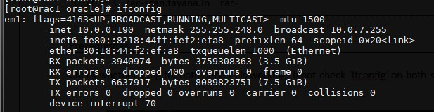

Should be like this. Else edit in [/etc/sysconfig/network-scripts/ifcfg-em1]. Note that LAN cable should be connected to ‘em1’ only.

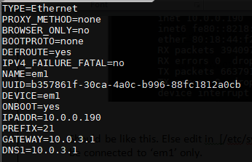

* + - * + PUT FIREWALL OFF ON BOTH THE SERVERS

systemctl status firewalled systemctl stop firewalled systemctl disable firewalled

Also

systemctl status NetworkManager systemctl stop NetworkManager systemctl disable NetworkManager

* + - * + vim /etc/selinux/config/ Set as SELINUX=disabled
        + Common partition

Common partition is the DA. In VMware, we are making the DA with additional HDD creation. Here we only need to connect via SAS cables to DA from servers to implement the same. So our common partition is ready which we can see in the ‘fdisk –l’ command.

* + - * + Run ntsysv and disable iptables, cups & enable rpc services, ntp service…
        + Uncomment and change followings in /etc/ssh/sshd_config UsePrivilegeSeparation no
        + service sshd restart
        + Append following in /etc/sysctl.conf kernel.shmall = 2097152

kernel.shmmax = 4247483648

kernel.shmmni = 4096

kernel.sem = 250 32000 100 128

fs.file-max =6815744

net.ipv4.ip_local_port_range = 9000 65500

net.core.rmem_default = 262144

net.core.rmem_max = 4194304

net.core.wmem_default = 262144

net.core.wmem_max = 1048576

fs.aio-max-nr = 1048576

* + - * + sysctl –p
        + Append the Following in /etc/security/limits.conf

**oracle soft nproc 2047 oracle hard nproc 16384 oracle soft nofile 1024 oracle hard nofile 65536**

* + - * + Installing ASM libraries

oracleasm-support-2.1.3-1.el5.x86_64.rpm oracleasmlib-2.0.4-1.el5.x86_64.rpm

kmod-oracleasm-2.0.6.rh1-2.el6.x86_64.rpm

* + - * + ORACLE ASM Configuration :

Sh /etc/init.d/oracleasm configure

Default user to own the driver interface []: oracle Default group to own the driver interface []: oinstall Start Oracle ASM library driver on boot (y/n) [n]: y Scan for Oracle ASM disks on boot (y/n) [y]: y

* + - * + Formating the shared disk (To be executed only on 1 node) fdisk –l

fdisk /dev/sdb (This should be the disk to be shared) n,p,enter,enter,w

* + - * + CREATING ASM DISKS – NODE 1

fdisk –l

/etc/init.d/oracleasm createdisk VOL1 /dev/sdb1

/etc/init.d/oracleasm listdisks VOL1

* + - * + SCANNING ASM DISKS – NODE 1

/etc/init.d/oracleasm scandisks

/etc/init.d/oracleasm listdisks VOL1

* + - * + Changing nslookup

mv /usr/bin/nslookup /usr/bin/nslookup1

Replace /usr/bin/nslookup with following and change permission chmod 775 /usr/bin/nslookup

Edit nslookup as shown below #################

#!/bin/bash if [ $2 ]; then

Addresses=`grep -w $2 /etc/hosts|grep -v -e ^# -e ^// |awk '{print $1}'|shuf` One_Address=`grep -w $2 /etc/hosts|grep -v -e ^# -e ^// |tail -1|awk '{print $1}'` Name=$2

elif [ $1 ]; then

Addresses=`grep -w $1 /etc/hosts|grep -v -e ^# -e ^// |awk '{print $1}'|shuf` One_Address=`grep -w $1 /etc/hosts|grep -v -e ^# -e ^// |tail -1|awk '{print $1}'` Name=$1

else

/usr/bin/nslookup1 fi

if [ $One_Address ]; then echo

echo "Server: etcfile Address: etcfile

Non-authoritative answer:" for Address in $Addresses; do

echo "Name: $Name Address: $Address" done

echo echo else

/usr/bin/nslookup1 $1 $2 fi

####################################

* + - * + NTP Server Details

[root@ptsdb2 opt]# cat /etc/sysconfig/ntpd # Drop root to id 'ntp:ntp' by default.

OPTIONS="-x -u ntp:ntp -p /var/run/ntpd.pid"

# Set to 'yes' to sync hw clock after successful ntpdate SYNC_HWCLOCK=no

# Additional options for ntpdate NTPDATE_OPTIONS=""

systemctl restart ntpdate.service

* + - * + Paste the following to /etc/profile

export ORACLE_HOME=/opt/oracle/product/12.2.0/dbhome_1 export PATH=$PATH:$ORACLE_HOME/bin

copy grid zip file to /opt/grid and unzip as oracle user

* + - * + 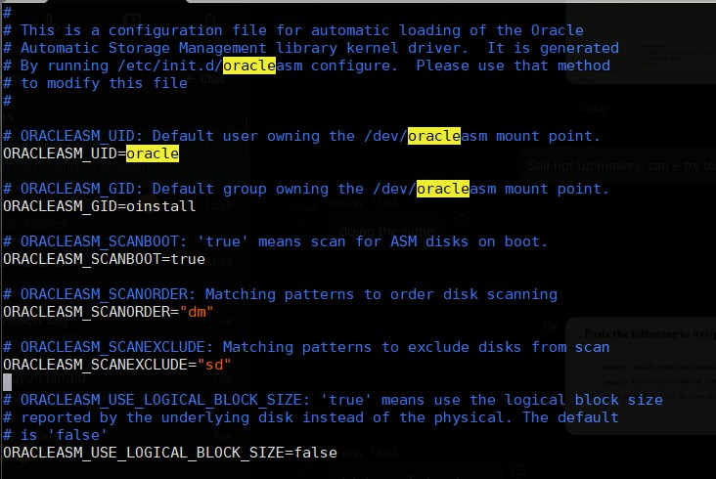Check in /etc/sysconfig/oracleasm In both nodes, It should be like this..

If not, edit and restart oracleasm service oracleasm status

service oracleasm stop service oracleasm status service oracleasm start

# GRID INSTALLATION

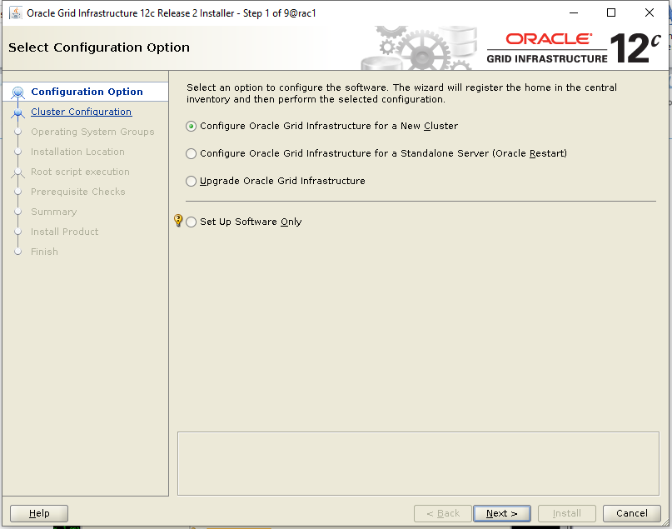

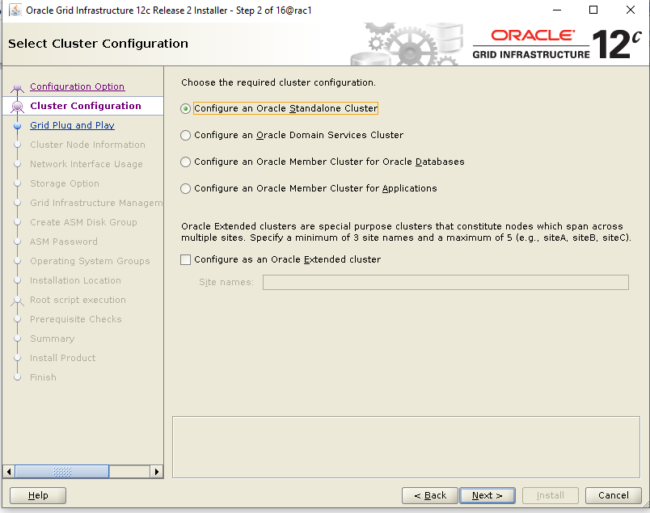

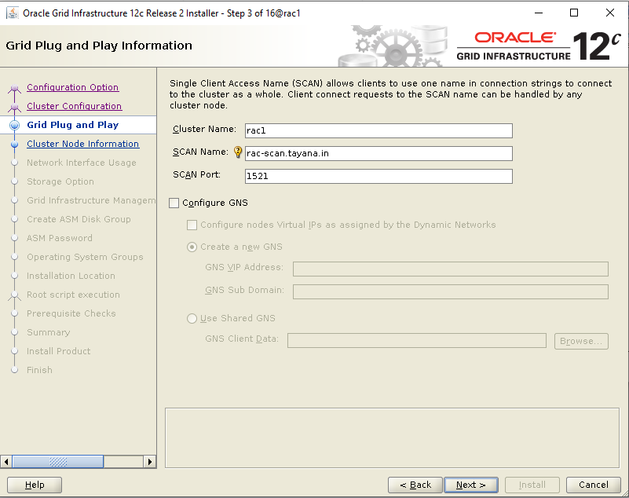

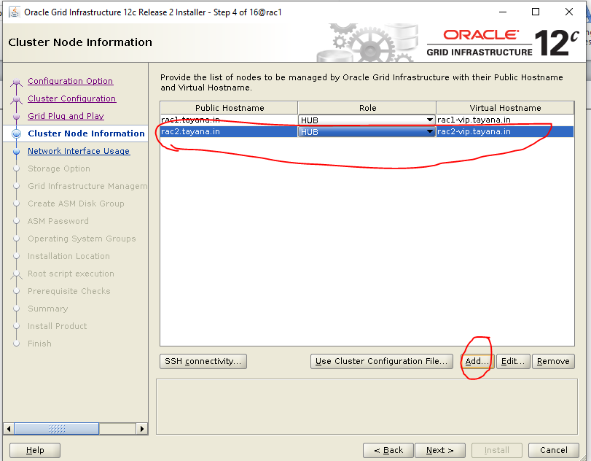

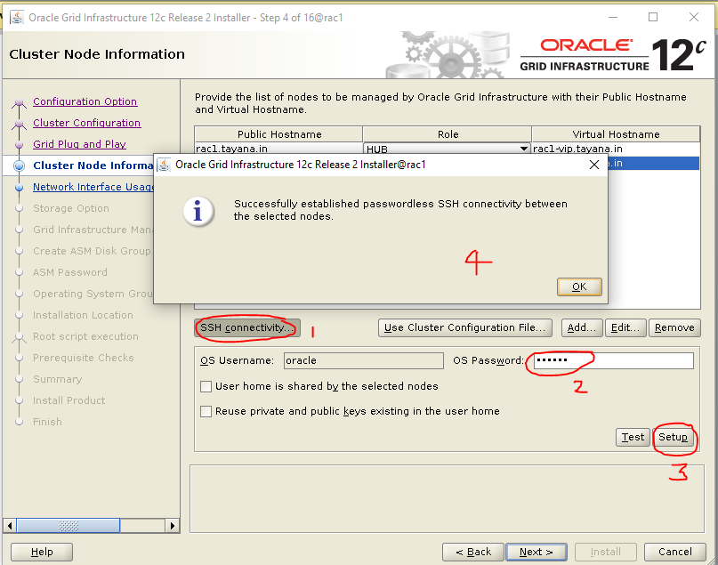

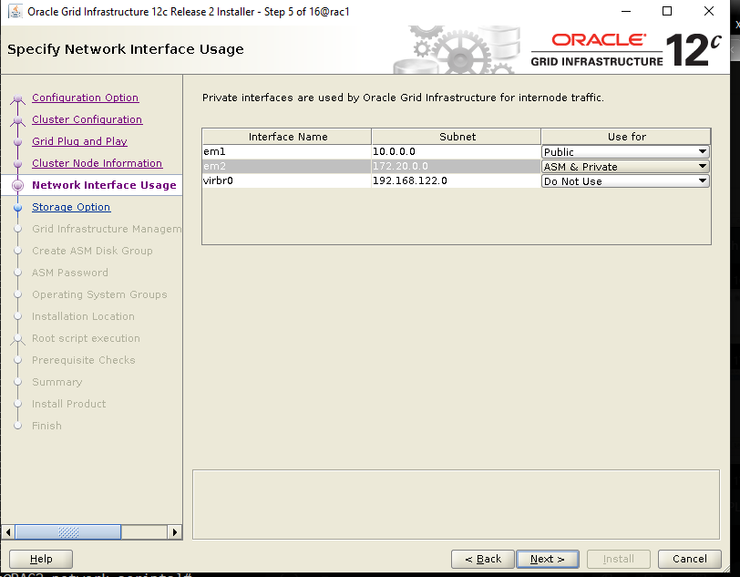

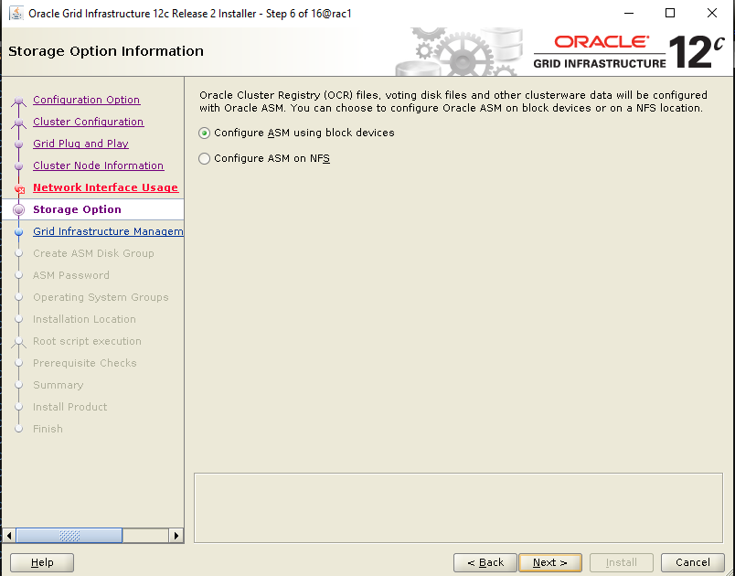

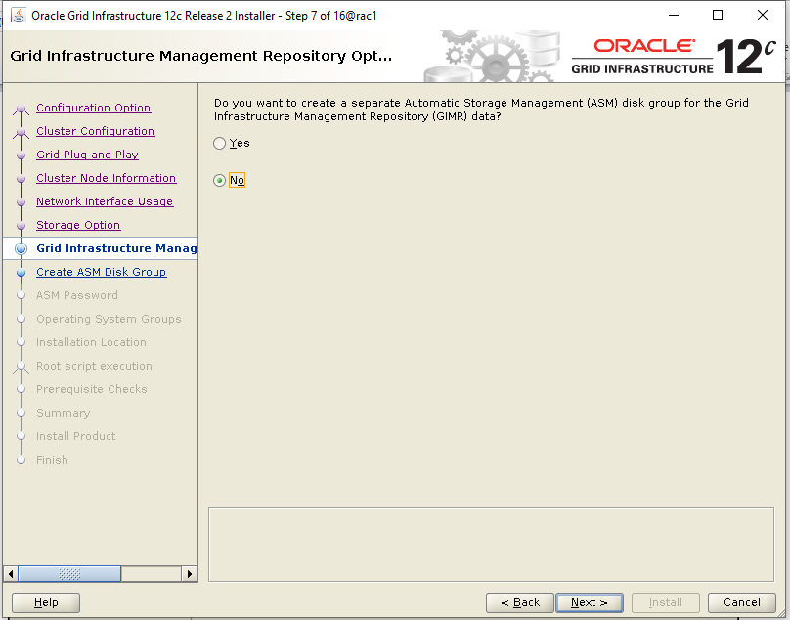

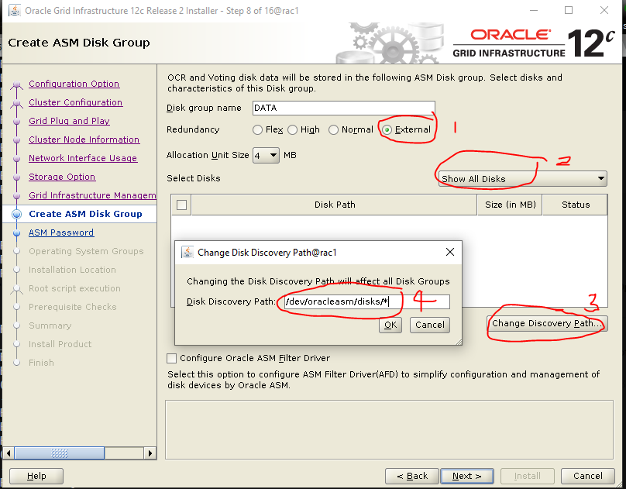

Path found from ‘/etc/oracleasm/disks/VOL1’

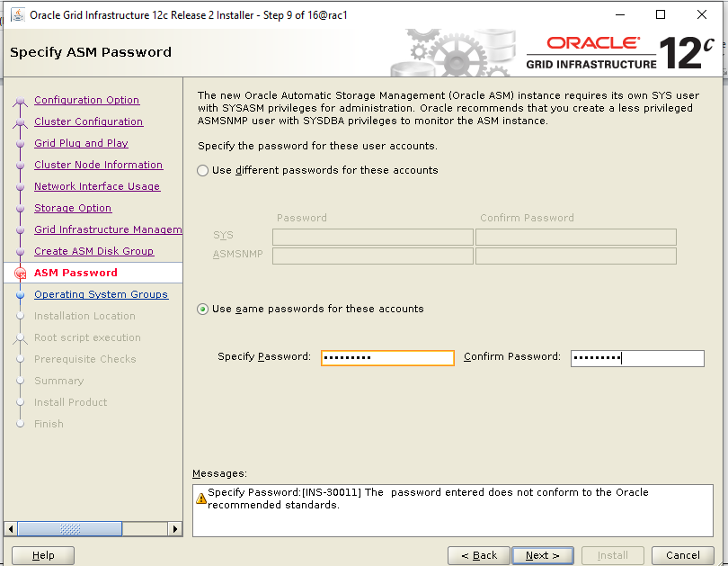

Password is ‘oracleasm’

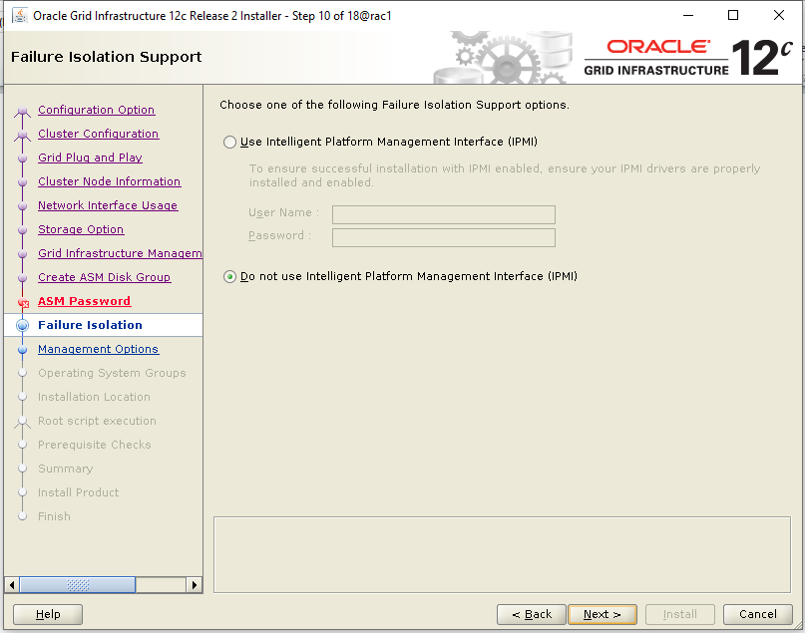

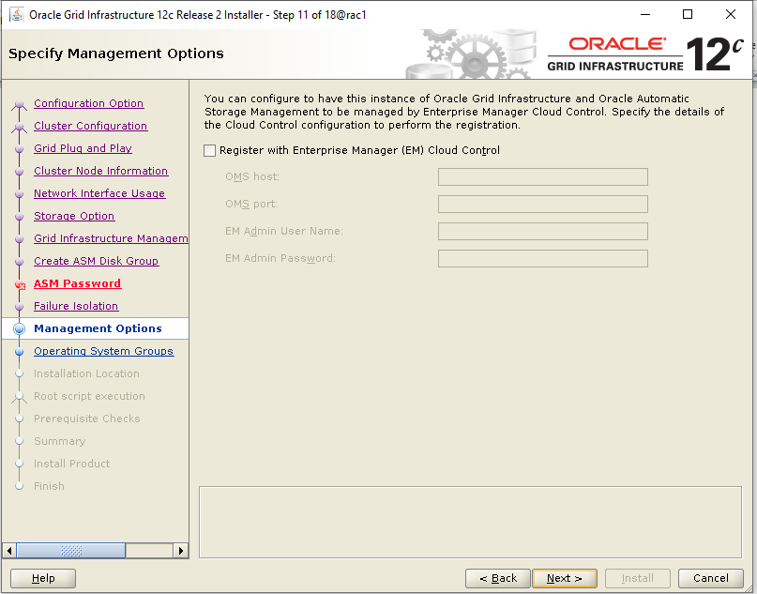

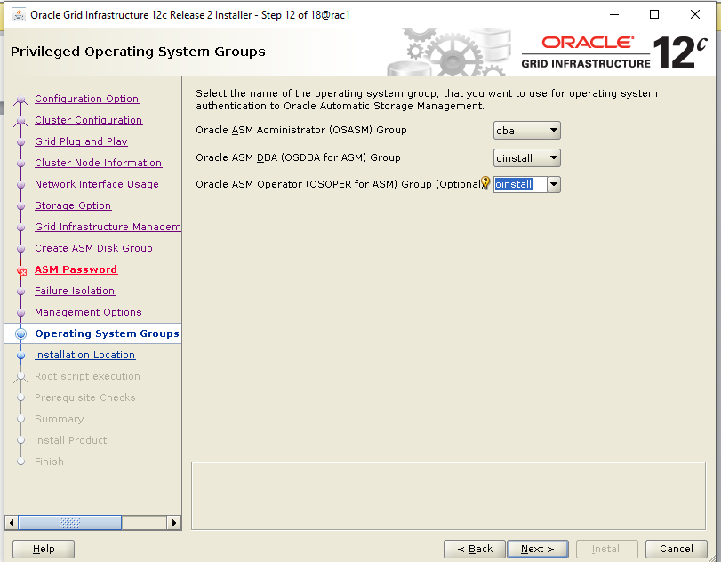

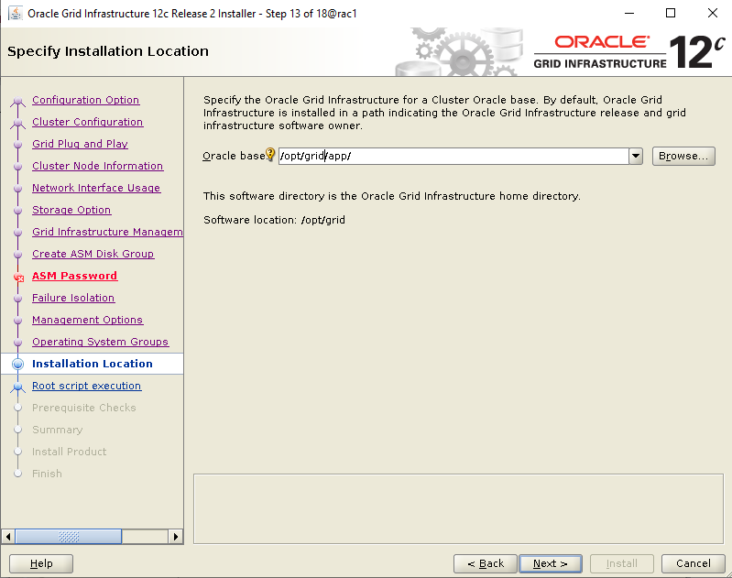

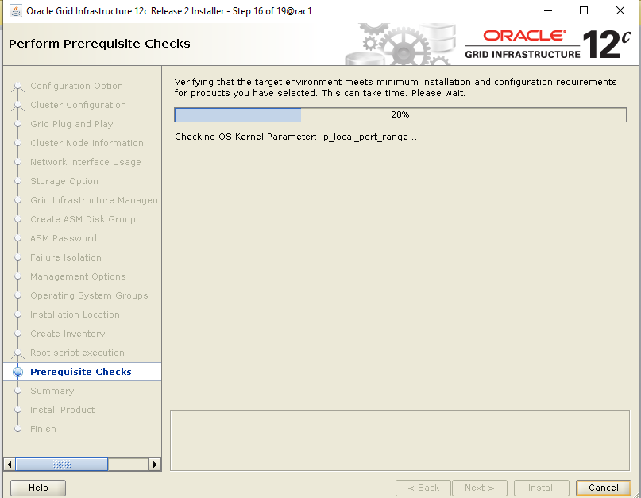

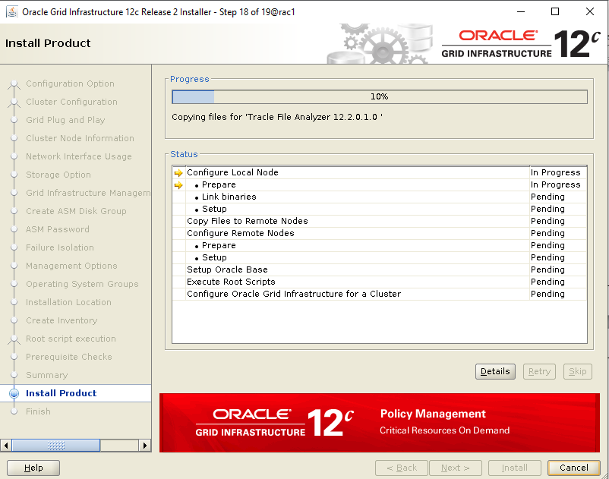

* FINISHED… (Oracle clusterware failed error you can skip)

IF ASM COMES UP IN BOTH NODES AND MULTIPATH IS ALSO FINE, we can go forward with DB

Installation

# DATABASE INSTALLATION

* move DB zip file to /opt/oracle/
* chown oracle.oinstall /opt/oracle/<zip file>
* ssh –X oracle@10.0.0.XXX
* Unzip file in /opt/oracle/
* cd database

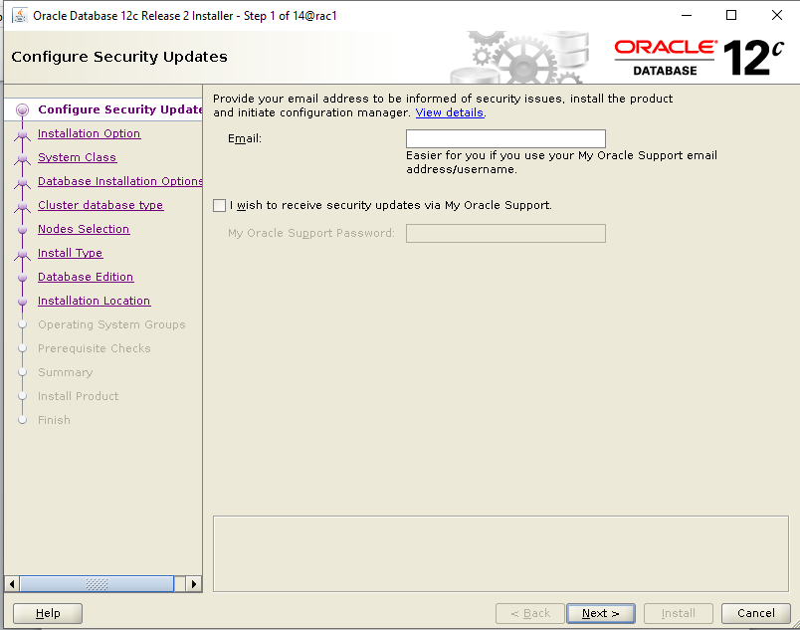

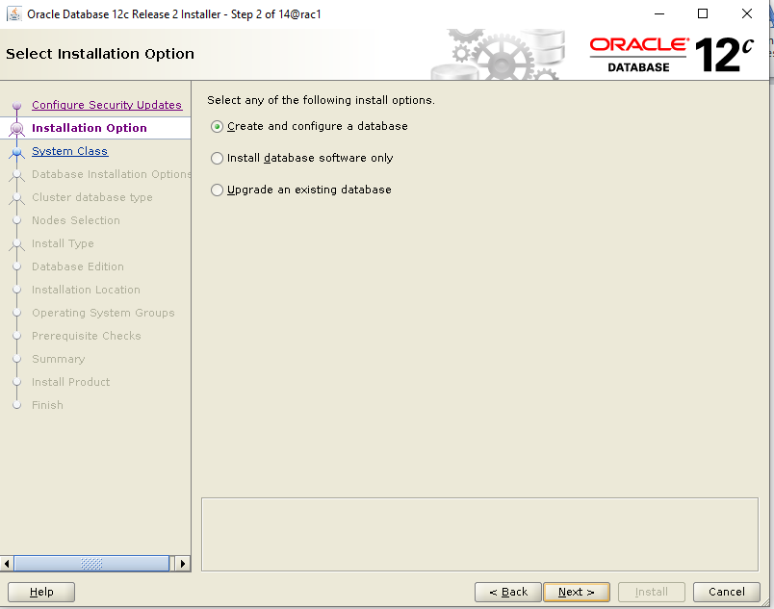

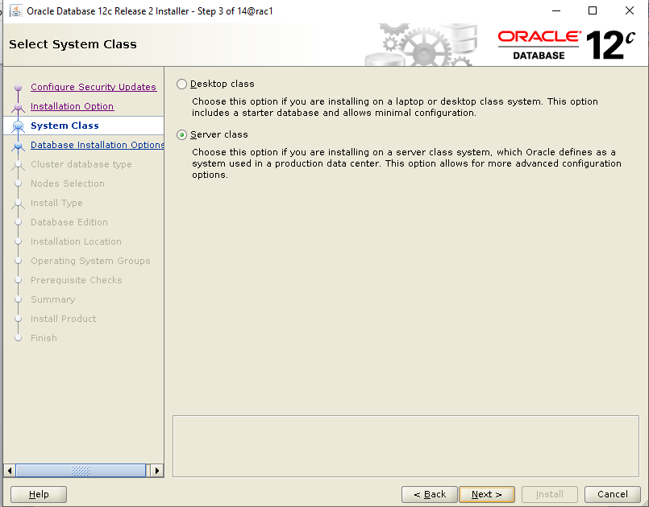

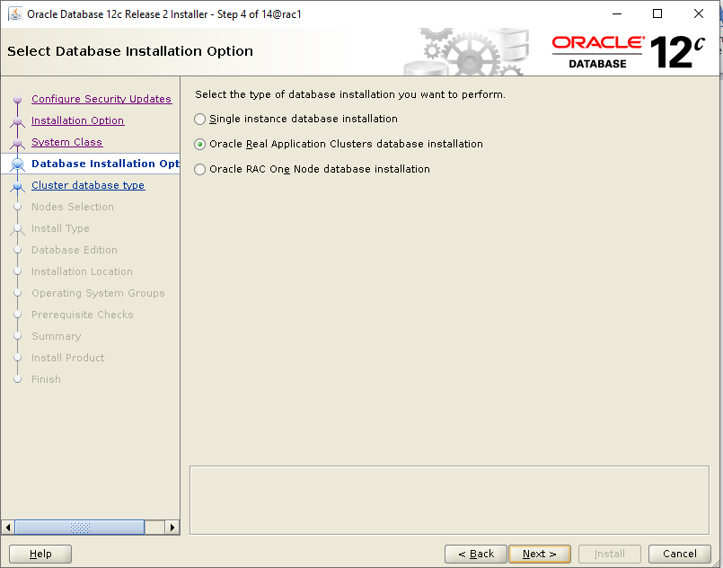

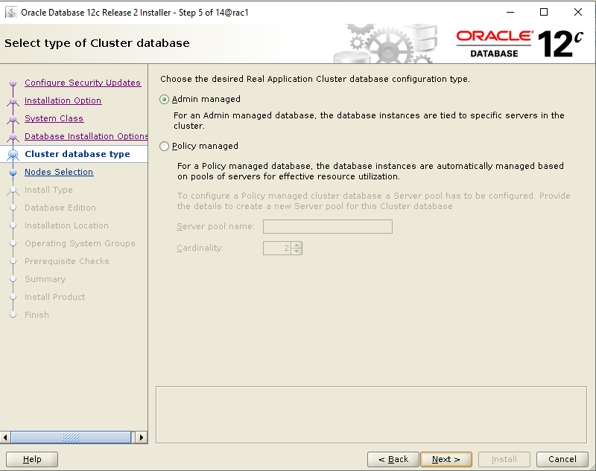

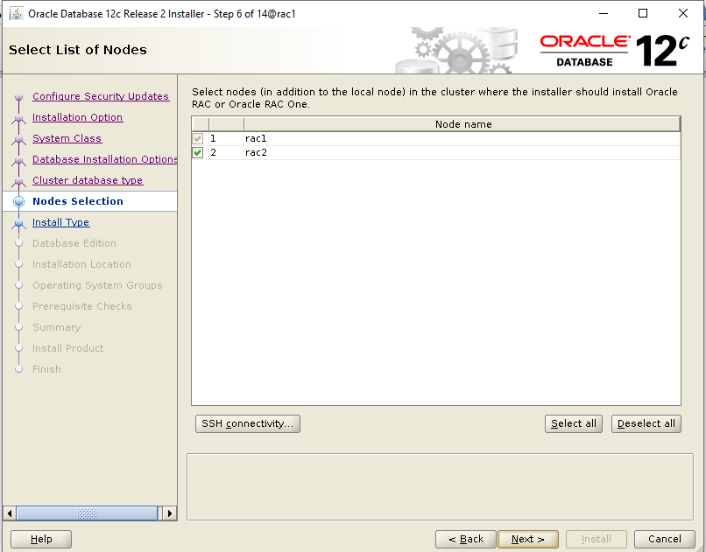

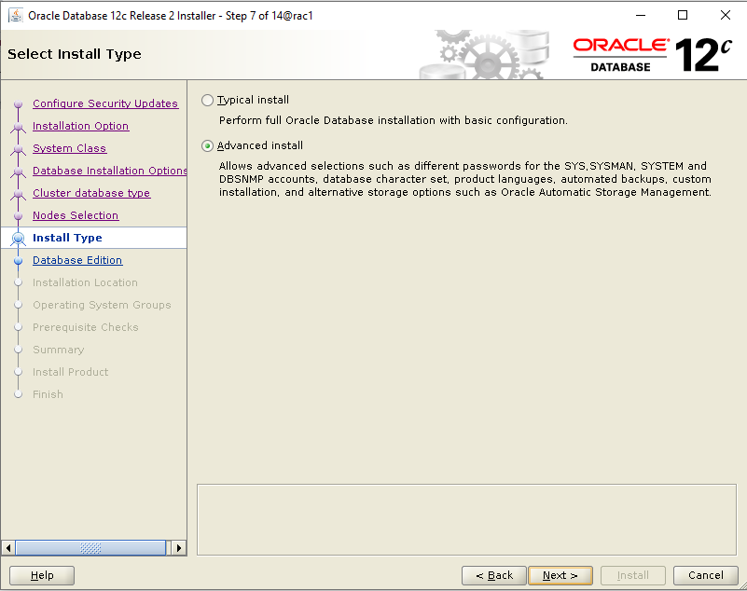

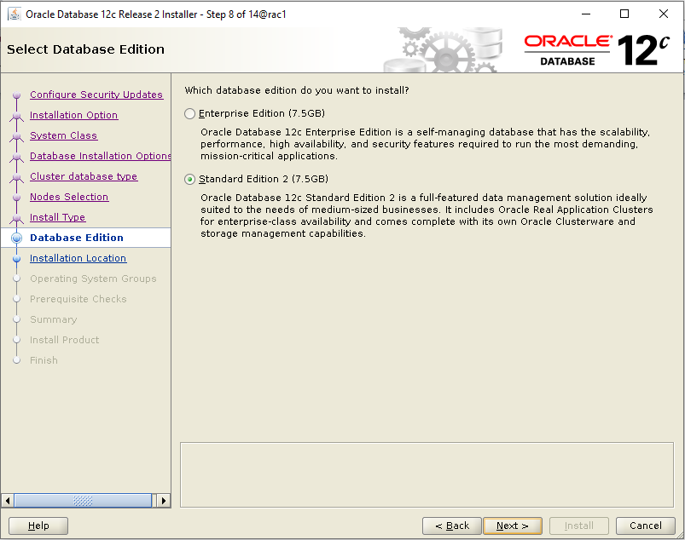

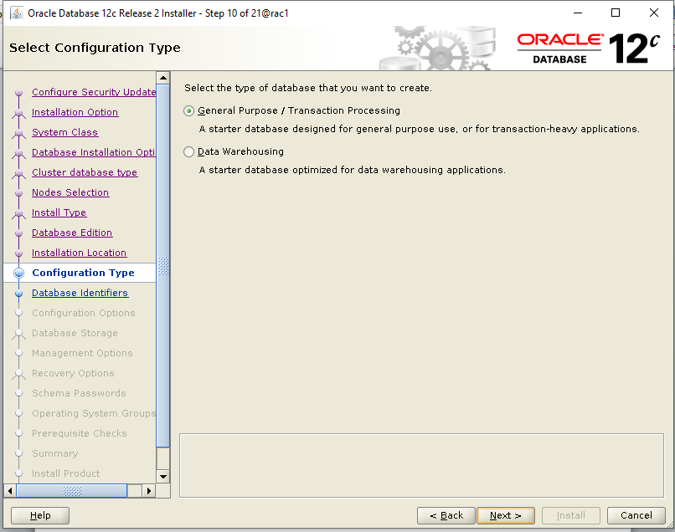

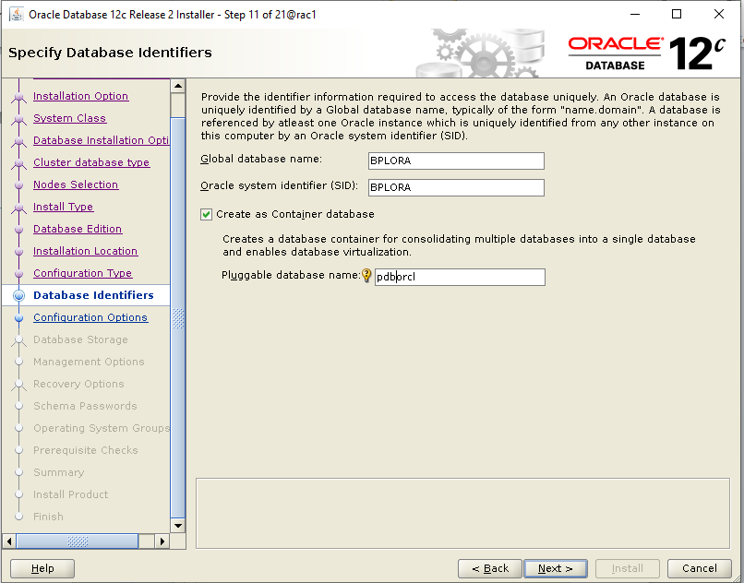

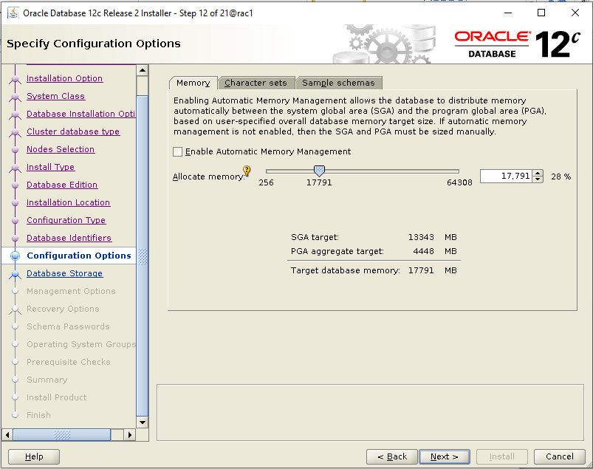

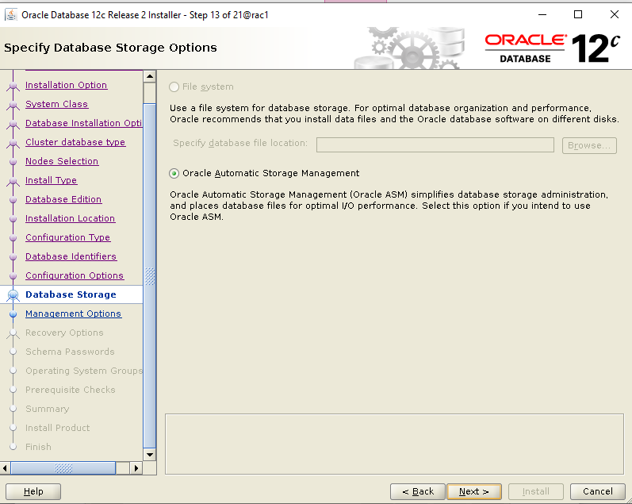

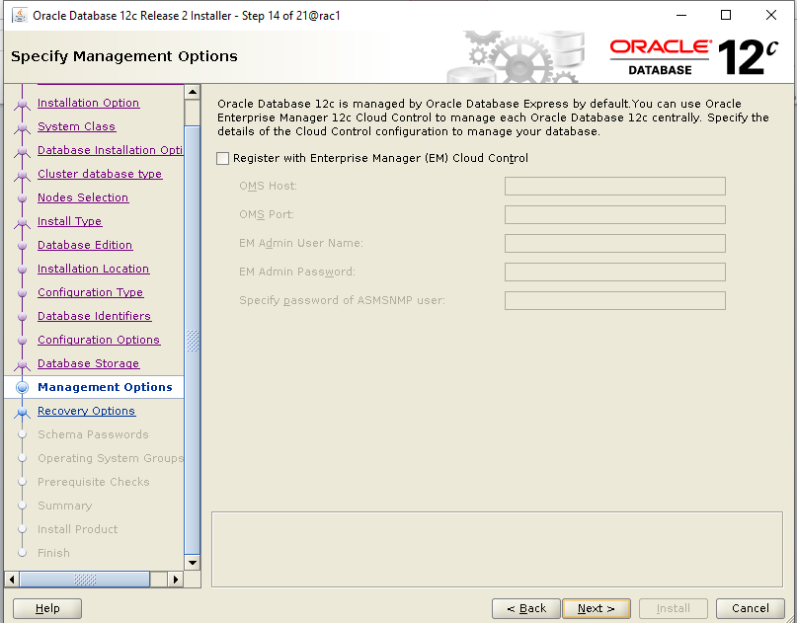

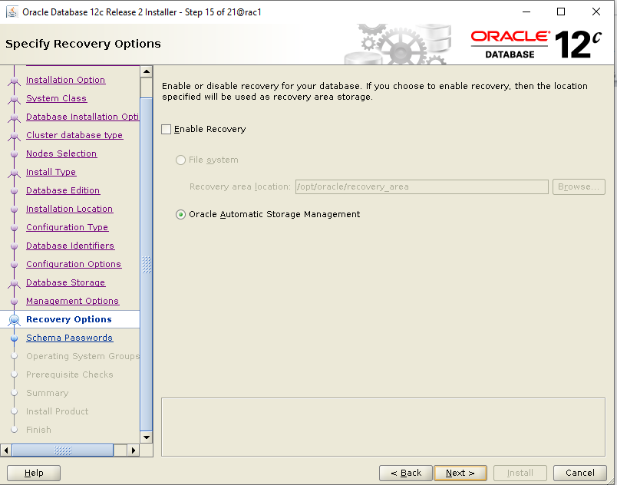

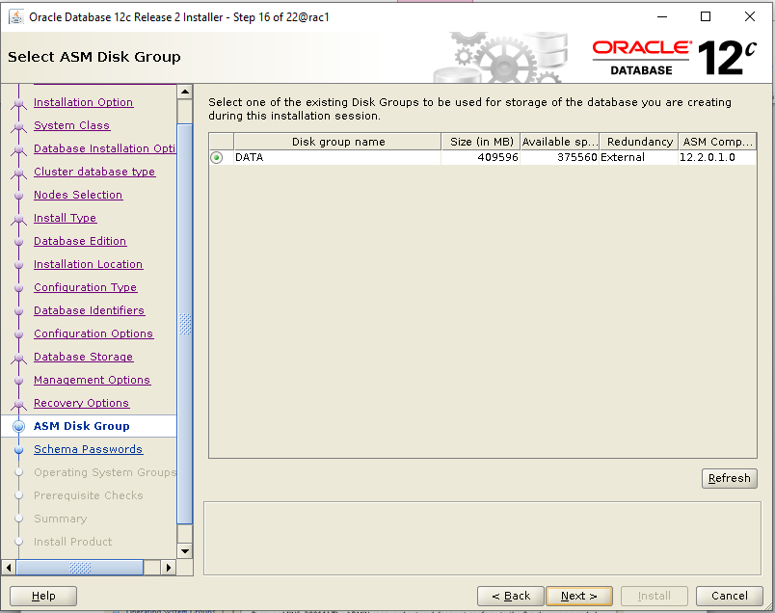

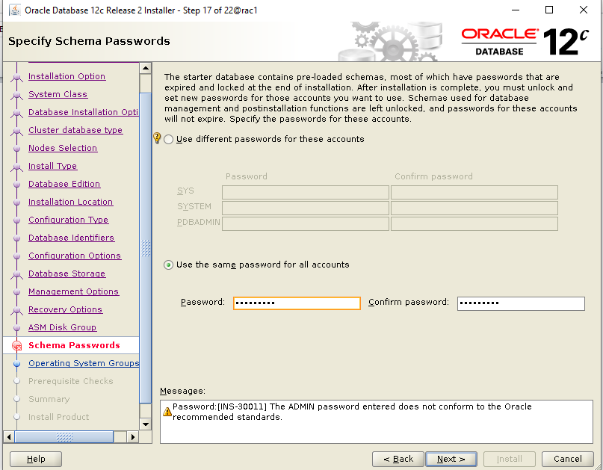

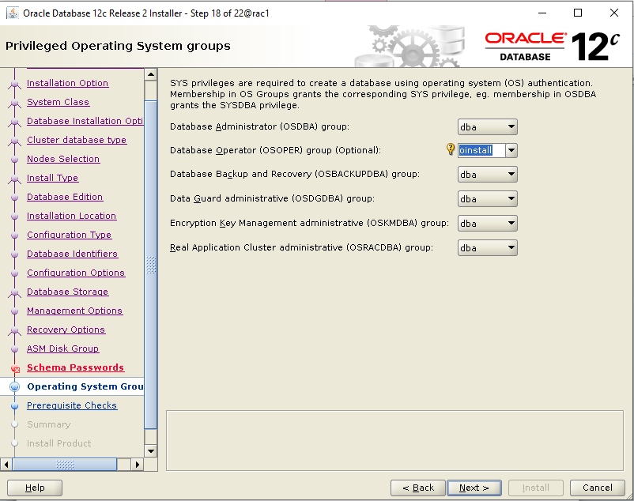

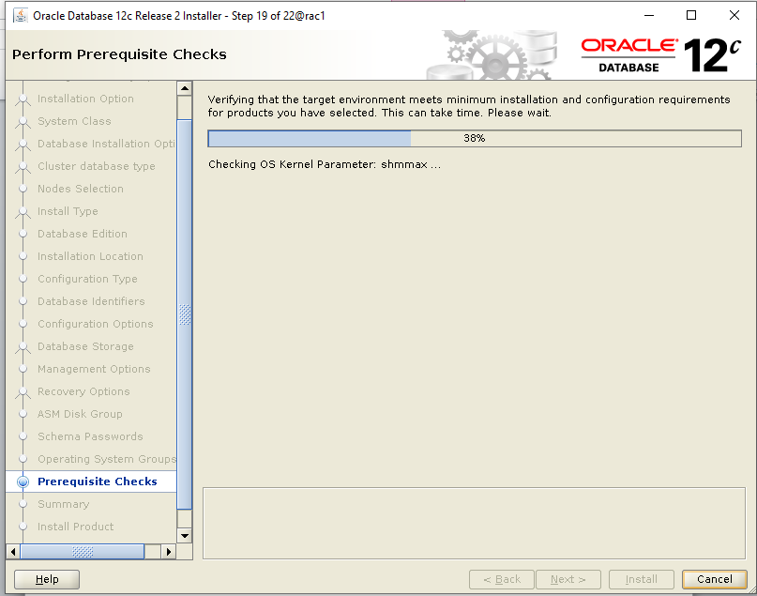

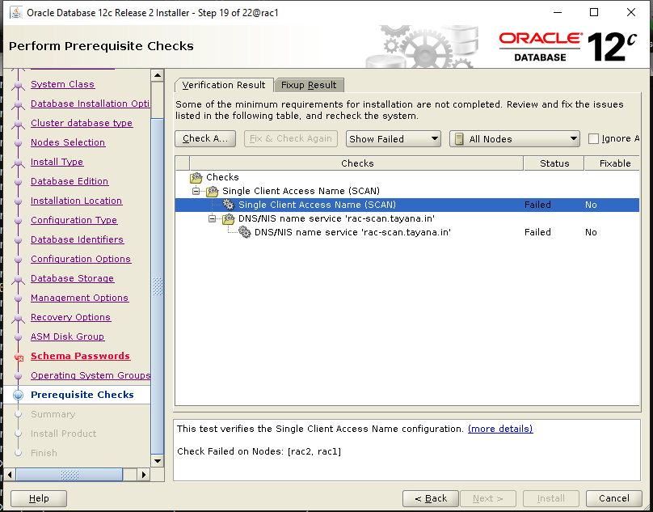

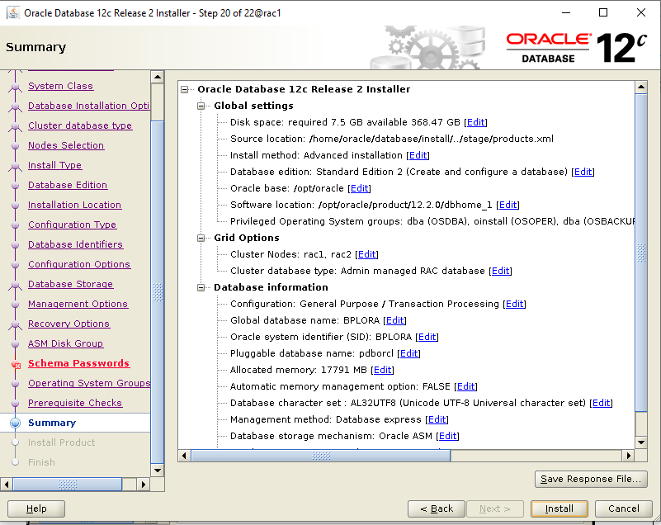

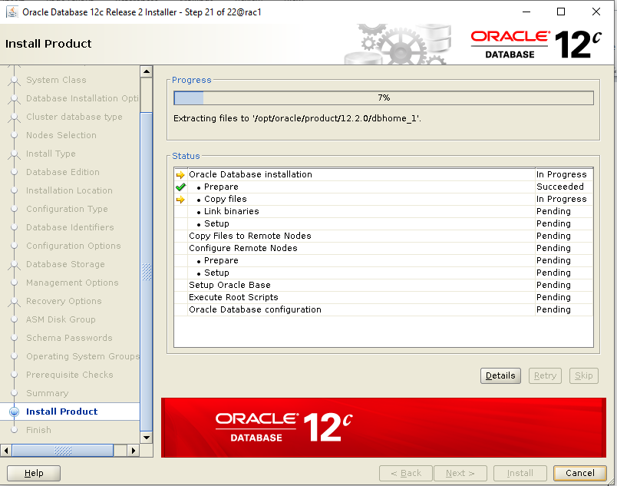

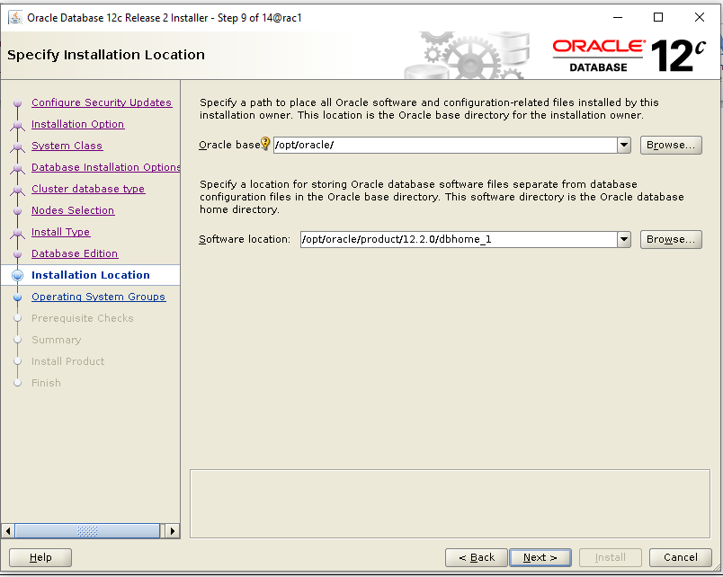

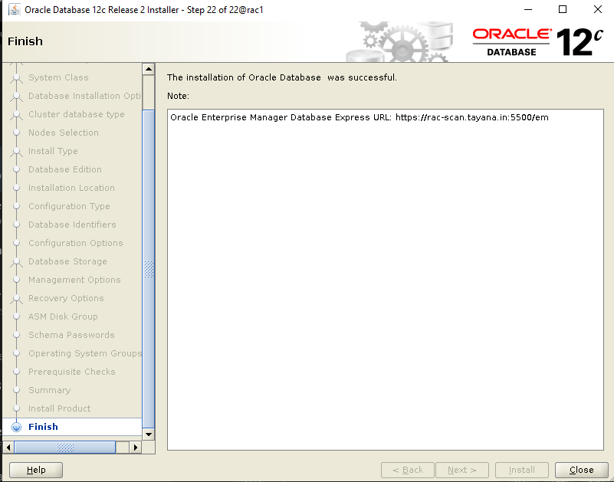

`

* Edit in the /etc/profile path the following (After properly checking the Oracle Home)

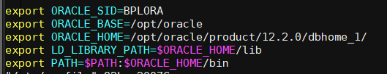

* Source etc/profile and try sqlplus to login to DB

**YOU HAVE SUCCESSFULLY COMPLETED ORACLE 12C GRID AND DB INSTALLATION … !**

*************************************************************************************